**EXPERIMENT-4.**

**PUSH BUTTON SWITCH INTERFACE-DOOR BELL CONTROL**

**AIM-***Design a door bell using push button.*

***APPARATUS-****Arduino,Resistance 470 ohm,wires,breadboard,push button*

**CIRCUIT DIAGRAM:**

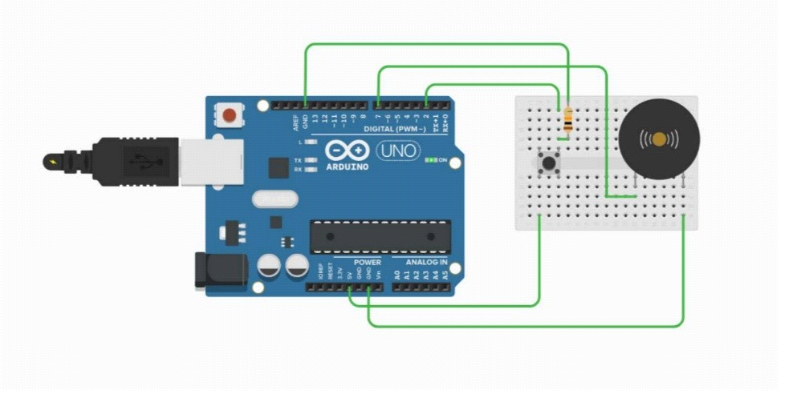

**THEORY**

**CONCEPT USED:-**

*We have used pushbutton as a switch*

*Each time you press the button,the bell will start making noise.*

**Learning and observation:-**

*I have learned how we can use switch to operate different devices.*

**Problem and troubleshooting:**

*Port selection should be done properly where you have connected arduino to the system .*

*connections were loose.*

*switch was not working.*

**Precautions:**

*Make sure the connections are proper.*

*Select the appropriate port.*

*Make sure the connections are not loose.*

**Learning outcome:**

*I learned how we can use a simple switch to make a door bell.*

*I also gained some basic knowledge of arduino.*